

Asset Type Tree Template – User Testing

Option 1

Scrore _____/10

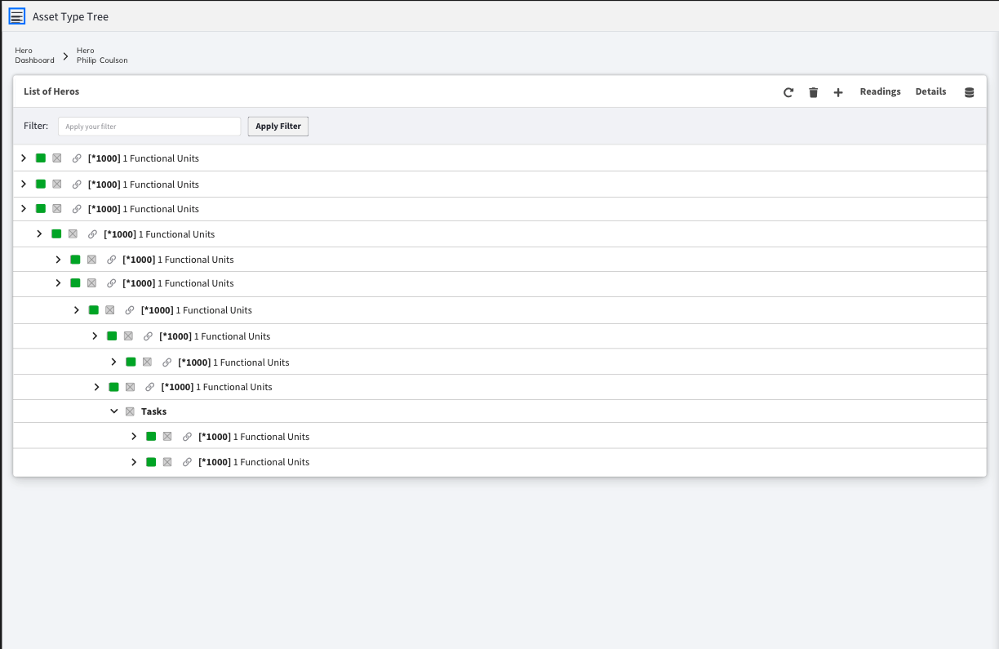

|  |  |
| --- | --- |
| PROS | CONS |
|  |  |

What is would you like added / removed / changed

____________________________________________________________________________________________________________________________________________________________________________________________________________________________________________________________________________________________________________________________________

Option 2

Scrore _____/10

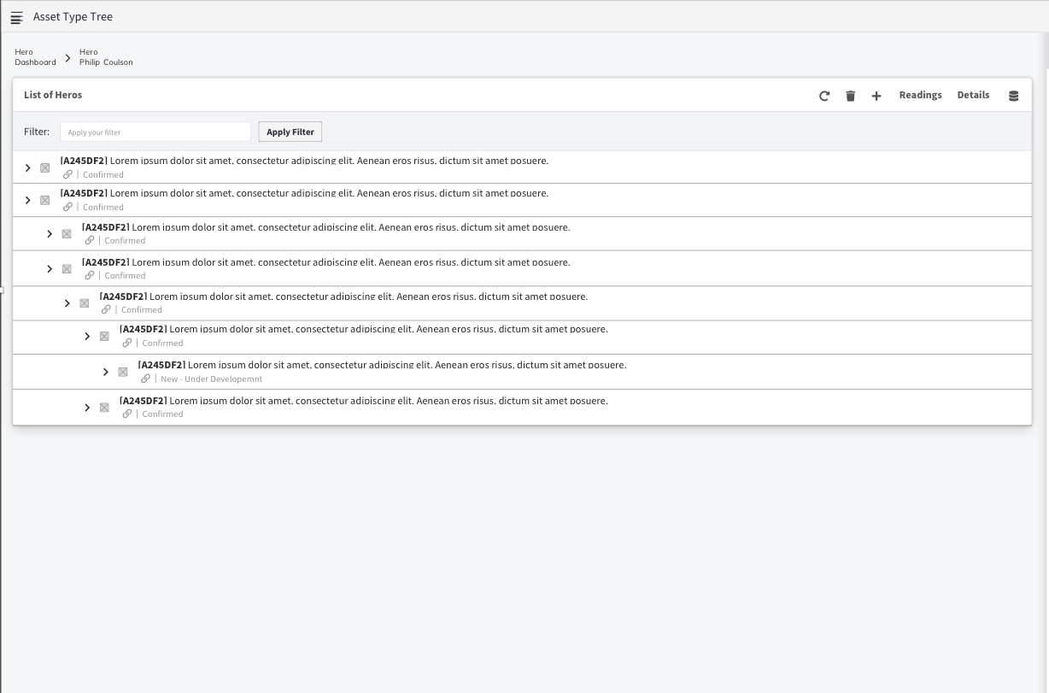

|  |  |
| --- | --- |
| PROS | CONS |
|  |  |

What is would you like added / removed / changed

____________________________________________________________________________________________________________________________________________________________________________________________________________________________________________________________________________________________________________________________________

Option 3

Scrore _____/10

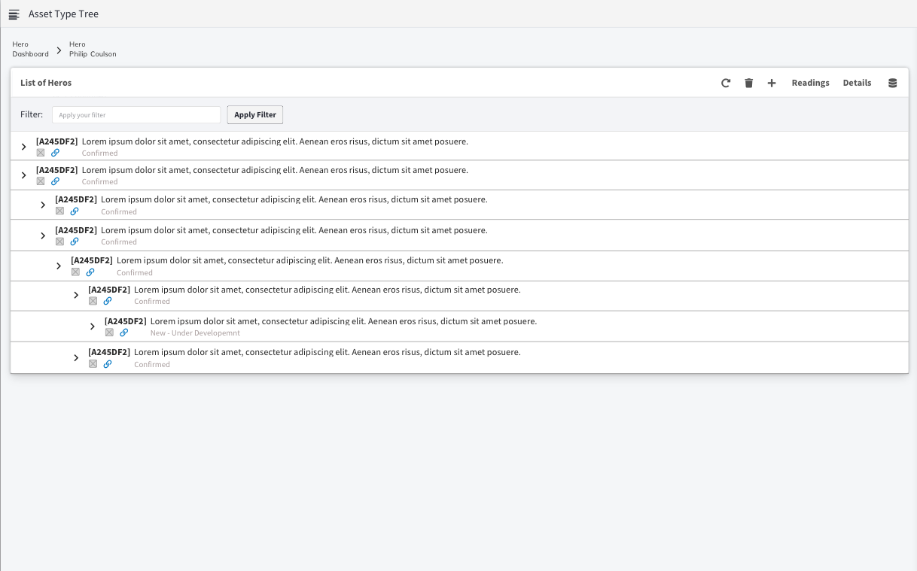

|  |  |
| --- | --- |
| PROS | CONS |
|  |  |

What is would you like added / removed / changed

____________________________________________________________________________________________________________________________________________________________________________________________________________________________________________________________________________________________________________________________________

Option 4

Scrore _____/10

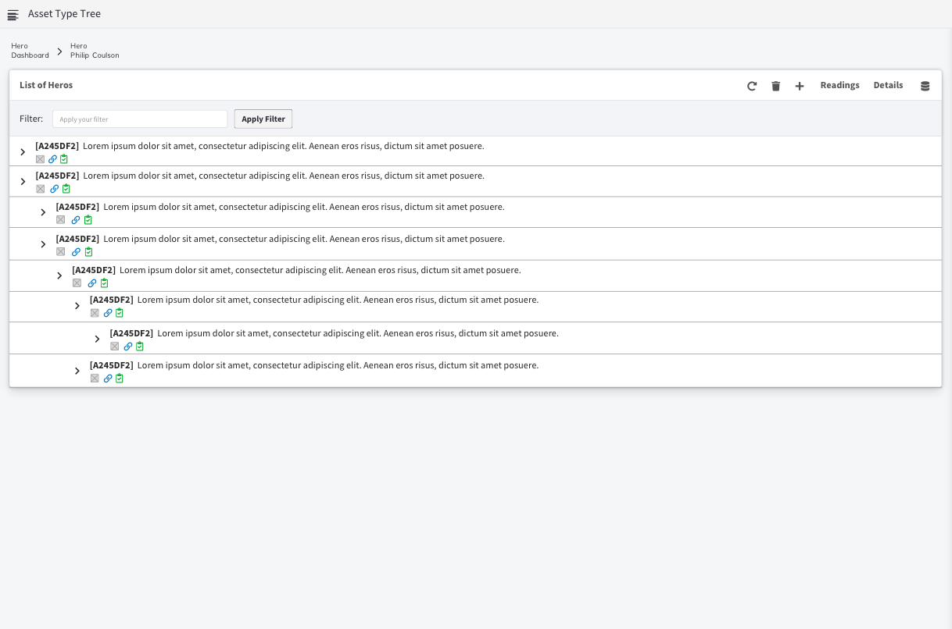

|  |  |
| --- | --- |
| PROS | CONS |
|  |  |

What is would you like added / removed / changed

____________________________________________________________________________________________________________________________________________________________________________________________________________________________________________________________________________________________________________________________________

Option 5

Scrore _____/10

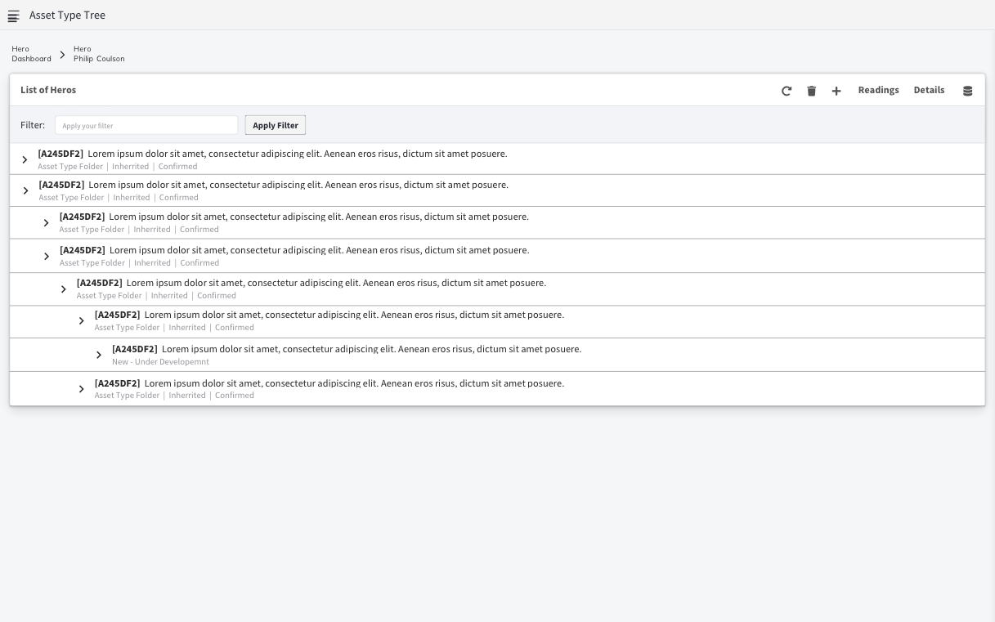

|  |  |
| --- | --- |
| PROS | CONS |
|  |  |

What is would you like added / removed / changed

____________________________________________________________________________________________________________________________________________________________________________________________________________________________________________________________________________________________________________________________________

Option 6

Scrore _____/10

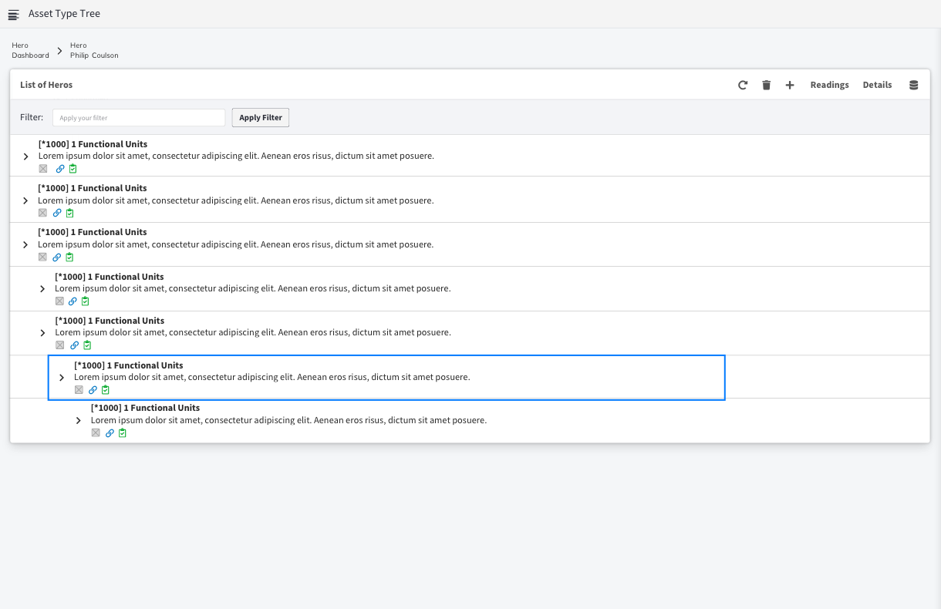

|  |  |
| --- | --- |
| PROS | CONS |
|  |  |

What is would you like added / removed / changed

____________________________________________________________________________________________________________________________________________________________________________________________________________________________________________________________________________________________________________________________________